1. SELECT table_schema, table_name, table_rows

FROM information_schema.tables;

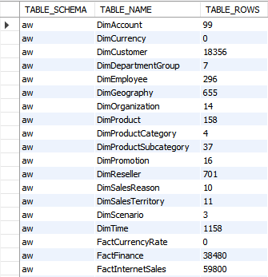

1. SELECT distinct table_schema, table_name, column_key

FROM information_schema.columns;

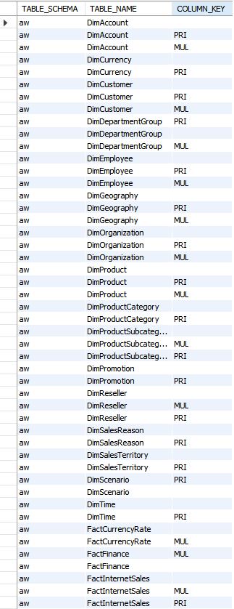

1. The standard table naming convention that AdventureWorksDW designers used when naming their tables was “CamelCase”. The designers added “Dim” at the beginning of the dimension table names and added “fact” at the beginning of the fact table names so we knew what type of table they are.
2. The purpose of the recursive relationship on DimEmployee was to allow the data warehouse to store the relationship between bosses and their employees as well as the other way around.
3. use aw;

SELECT distinct EnglishProductSubcategoryName

FROM DimProduct p, FactInternetSales s, DimProductSubcategory c

where p.ProductKey = s.ProductKey and p.ProductSubcategoryKey = c.ProductSubcategoryKey

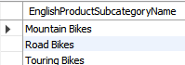

use aw;

Select distinct P.Color, D.CalendarYear, sum(F.OrderQuantity) as 'sum'

from FactInternetSales F, DimProduct P, DimTime D

where D.CalendarYear = '2001' and F.ProductKey = P.ProductKey and

P.ProductSubcategoryKey < 4

group by P.Color

order by sum desc;

Select distinct P.Color, D.CalendarYear, sum(F.OrderQuantity) as 'sum'

from FactInternetSales F, DimProduct P, DimTime D

where D.CalendarYear = '2002' and F.ProductKey = P.ProductKey and

P.ProductSubcategoryKey < 4

group by P.Color

order by sum desc;

Select distinct P.Color, D.CalendarYear, sum(F.OrderQuantity) as 'sum'

from FactInternetSales F, DimProduct P, DimTime D

where D.CalendarYear = '2003' and F.ProductKey = P.ProductKey and

P.ProductSubcategoryKey < 4

group by P.Color

order by sum desc;

Select distinct P.Color, D.CalendarYear, sum(F.OrderQuantity) as 'sum'

from FactInternetSales F, DimProduct P, DimTime D

where D.CalendarYear = '2004' and F.ProductKey = P.ProductKey and

P.ProductSubcategoryKey < 4

group by P.Color

order by sum desc;

2001:

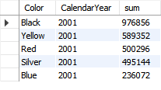

2002:

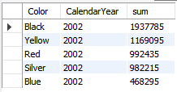

2003:

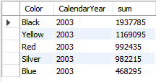

2004:

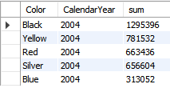

The most popular color of bike sold in 2001 was “**Black**” with 976,856 black bikes sold.

The most popular color of bike sold in 2002 was “**Black**” with 1,937,785 black bikes sold.

The most popular color of bike sold in 2003 was “**Black**” with 1,937,785 black bikes sold.

The most popular color of bike sold in 2004 was “**Black**” with 1,295,396 black bikes sold.

use aw;

SELECT G.StateProvinceName, D.CalendarYear, sum(F.SalesAmount) as 'Sum'

FROM FactInternetSales F, DimCustomer C, DimGeography G, DimProduct P, DimTime D

Where D.CalendarYear = '2001' and F.ProductKey = P.ProductKey and

F.CustomerKey = C.CustomerKey And G.GeographyKey = C.GeographyKey And P.ProductSubcategoryKey < 4

group by G.StateProvinceName

order by Sum desc

limit 4;

SELECT G.StateProvinceName, D.CalendarYear, sum(F.SalesAmount) as 'Sum'

FROM FactInternetSales F, DimCustomer C, DimGeography G, DimProduct P, DimTime D

Where D.CalendarYear = '2002' and F.ProductKey = P.ProductKey and

F.CustomerKey = C.CustomerKey And G.GeographyKey = C.GeographyKey And P.ProductSubcategoryKey < 4

group by G.StateProvinceName

order by Sum desc

limit 4;

SELECT G.StateProvinceName, D.CalendarYear, sum(F.SalesAmount) as 'Sum'

FROM FactInternetSales F, DimCustomer C, DimGeography G, DimProduct P, DimTime D

Where D.CalendarYear = '2003' and F.ProductKey = P.ProductKey and

F.CustomerKey = C.CustomerKey And G.GeographyKey = C.GeographyKey And P.ProductSubcategoryKey < 4

group by G.StateProvinceName

order by Sum desc

limit 4;

SELECT G.StateProvinceName, D.CalendarYear, sum(F.SalesAmount) as 'Sum'

FROM FactInternetSales F, DimCustomer C, DimGeography G, DimProduct P, DimTime D

Where D.CalendarYear = '2004' and F.ProductKey = P.ProductKey and

F.CustomerKey = C.CustomerKey And G.GeographyKey = C.GeographyKey And P.ProductSubcategoryKey < 4

group by G.StateProvinceName

order by Sum desc

limit 4;

2001:

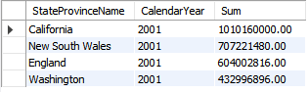

2002:

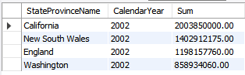

2003:

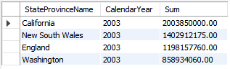

2004:

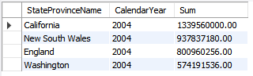

The 4 state/provinces that showed the highest sales volume for each of the years 2001-2004 were California, New South Wales, England, and Washington for all 4 years.

use aw;

Select distinct P.EnglishProductName, D.CalendarYear, sum(F.UnitPrice - F.ProductStandardCost) as "Margin"

from FactInternetSales F, DimProduct P, DimTime D

where D.CalendarYear = '2002' and F.ProductKey = P.ProductKey and

P.ProductSubcategoryKey < 4

group by P.EnglishProductName

order by Margin desc;

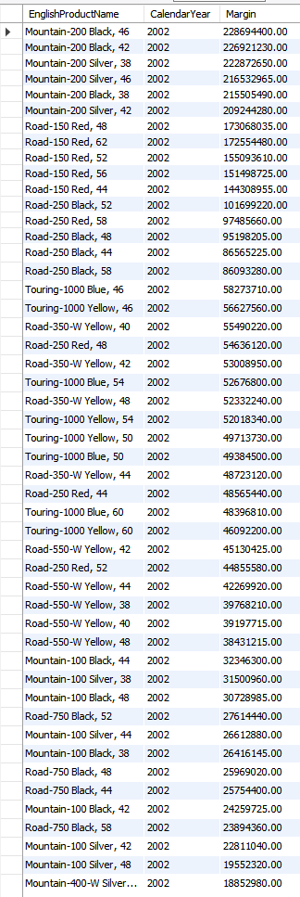

The “Mountain-200 Black, 46” yielded the highest margin for AdventureWorks in the year 2002. You can tell this because I ordered the table by the highest margin on top then descending order from there and the “Mountain-200 Black, 46” is the top model on the table.